
A 10
SET NO : 2

Sreenidhi Institute of Science & Technology
(An Autonomous Institution)
Code No:

B. TECH. I – Year I – Semester Examinations, May, 2011 (Supplementary)
ENGINEERING MATHEMATICS (EEE, ME & CSE)

Time: 3 Hours Max. Marks : 70

Note : No additional answer sheets will be provided.

Part-A (Objective Type)
Max.Marks:20

Answer all QUESTIONS.

1. Obtain the matrix form of quadratic equation q = x²-6xy+3y².

2. Find the critical points of the function x³+3x²y-3y²+4.

3. Evaluate 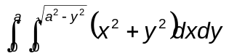by changing into polar coordinates.

4. Find the matrix A, if 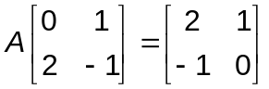.

5. Find the asymptotes of the curve y²(x-a)=x²(x+a).

6. Find the product of the Eigenvalues of the matrix 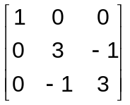.
7. Verify the continuity of the function 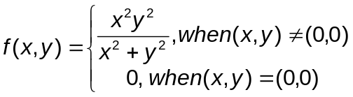

8. Test the convergence of the series 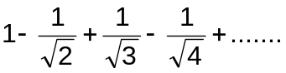.

9. Verify Rolle's theorem for f(x) = e^{x} (sinx-cosx) in 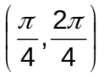.

10. Find the radius of curvature at the point (p, r) on the ellipse 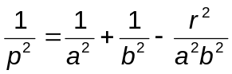.

Part – B
Max. Marks: 50

ANSWER ANY FIVE QUESTIONS.
EACH QUESTION CARRIES 10 MARKS.

1. a) Prove that JJ| =1, when x = u cos θ and y = u sin θ. [ 5 ]

b) Find the maximum and minimum distances of the point (3,4,12) from the sphere x²+y²+z² = 1 . [ 5 ]

2. a) Trace the curve a²y² - x² (a² - x²) = 0. [ 5 ]

b) Trace the curve given by r - a (1+sinθ) = 0. [ 5 ]

3. a) Find the length of the loop of the curve 3ay² = x(x-a) ² [ 5 ]

b) Evaluate 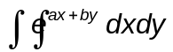 over the triangle x = 0, y=0, ax+by=1. [ 5 ]

4. a) Show that the evaluate of the Cycloid x = a (θ - sin θ), y = a(1-cosθ) is another equal cycloid. [ 5 ]

b) Find the envelope of a system of concentric and coaxial ellipse of constant area.
[ 5 ]
5. Verify Cayley-Hamiltons theorem for the matrix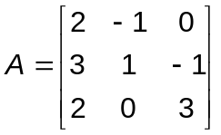.Hence find A⁻¹ and A³.
6. a) Obtain the inverse of the matrix 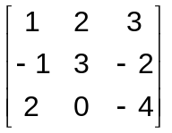 by elementary transformations.
[ 5 ]

b) Solve the system of equations 2x-y+4z=12; 3x+2y+z=10;x+y+z=6, if it is consistent. [ 5 ]

7. Find the Eigenvalues and corresponding Eigenvectors of the matrix 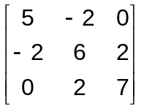.
8. a) Test the convergence of the series 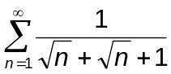. [ 5 ]

b) Test for convergence, absolute / conditional convergence of the series 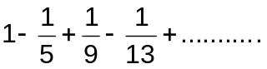. [ 5 ]

- 0 - 0 -

